Azure Cosmos DB

Integrate the above deployed Azure function with all the Cosmos DB and retrieve the logs.

Step 1: Open the azure functtion which was created.

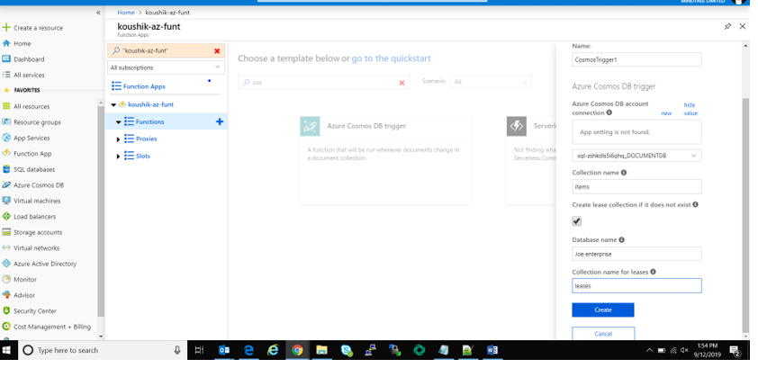

Step 2: Click on integrate. Enter the respected details and save.

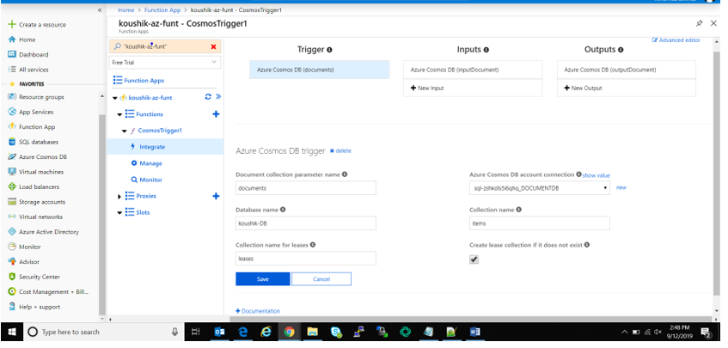

Step 3: Go to the cosmos DB database and add some data.

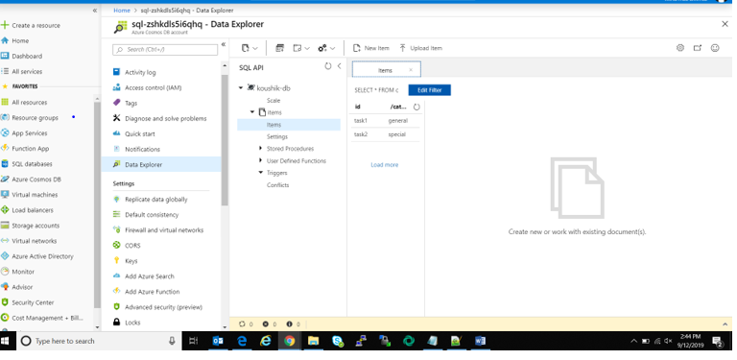

Step 4: Now go back to the function.

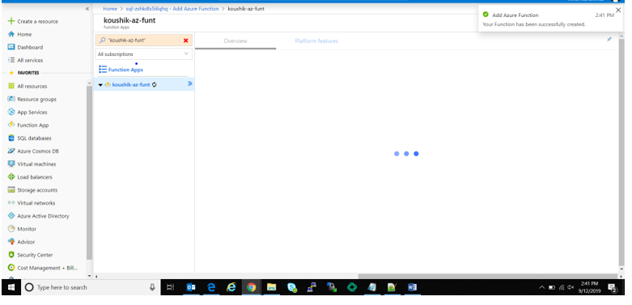

Step 5: Check for the activity log.

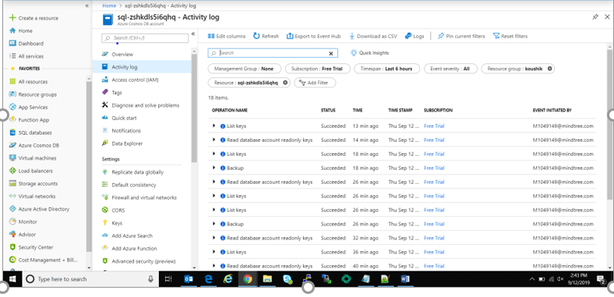

Step 6 : Click on the CosmosTrigger and Run the index.js. The logs will be available.

